Curriculum Vitae Ismo Laakso
Ismo Laakso  Turku Archipelago, Finland  040 5231004  iwaslaakso@gmail.com  Date of birth 14 April 1959  Place of birth Turku | 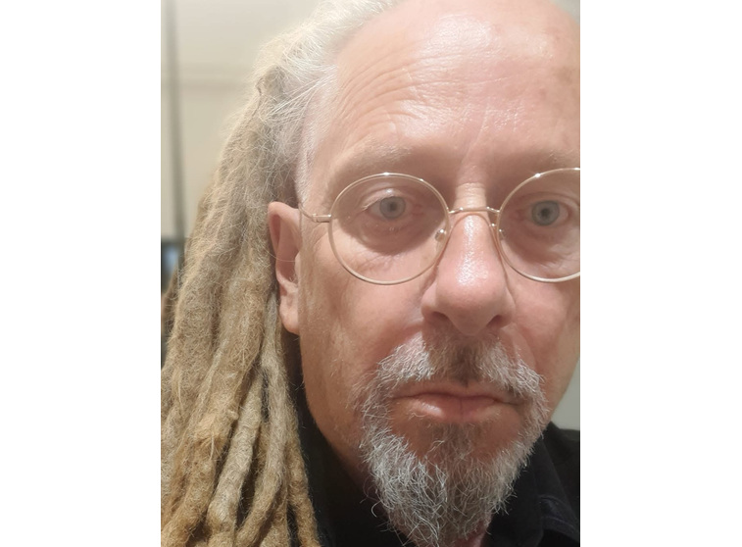
Ismo Laakso is a Finnish composer, sound artist, conductor and multi-instrumentalist whose music combines industrial and classical influences.

Performing arts
- Since the late 1970s, he has composed more than 120 works for theatre and dance stages, performed both in Finland and abroad.

The 2000s
- “Tässä olen” was created in collaboration with choreographer Ervi Sirén, dancer Urmas Poolamets and musician Ismo Laakso. Aurinkobaletti, 2021.
- In 2016, conductor of “The Rocky Horror Show”, directed by Sami Saikkonen. Performances at Kulttuuritalo in Helsinki, Logomo in Turku and Tampere Hall in Tampere.
- In 2015, Laakso conceived, directed and composed “Erzsébet Workshop” for the studio stage of Åbo Svenska Teater.
- Visiting conductor at Turku City Theatre (also composer, arranger, sound designer and musician), 1999–2004; permanent conductor at the City Theatre, 2005–2015.
- One of the most significant productions was “12 Karamazovia” (2011), directed by Kristian Smeds, for which Laakso served as musical director. Performances in Tallinn, Turku, Berlin, Hamburg and Riga. In 2012, the work appeared at both the Tampere Theatre Festival and the Helsinki Festival.
- In 2009, “H8 – Renessanssiprinssi” with Aurinkobaletti; choreography by Urmas Poolamets, music composed and conducted by Ismo Laakso.
- In 2005, together with Aurinkobaletti and Åbo Svenska Teater, “Urvind”, a play based on a work by Bo Carpelan and directed by Maiju Sallas.
- Collaborators during his time as conductor at Turku City Theatre included Ville Sandqvist, Fiikka Forsman, Hannu Raatikainen, Tiina Brännare, Katariina Lahti, Maarit Ruikka, Juha Hurme, Pentti Kotkaniemi, Maiju Sallas, Jussi Helminen and Marika Vapaavuori.

Before the turn of the millennium
- 1998–99, a work created in collaboration with Susanna Veijalainen for Zodiak – Center for New Dance, Helsinki.
- In 1997, “Jokishakki”, a dance and music performance choreographed by Metsälintu Pahkinen and composed by Ismo Laakso, in which the stage was built over the river and the River Aura served as the amphitheatre.
- In 1996, the dance work “Ofelia”, created in collaboration with Kirsi Monni for the Helsinki Festival.
- In the 1990s, close collaboration with Aurinkobaletti. Music for productions choreographed by, among others, Kirsi Monni, Ari Numminen and Raija Lehmussaari. In addition to Finland’s largest cities, performances took place in St Petersburg, Tallinn and Hong Kong.
- In the early 1980s, several joint productions with Turku University Theatre and Turku New Theatre.

Film
- In 2015, a short film based on Laakso’s aforementioned stage work “Erzsébet Workshop” (https://www.facebook.com/ErzsebetWorkshop/).
- Collaboration with artist Harri Larjosto, including composing for the films “Vesikertomuksia / Water Stories” (1999) and “Kulkutauti / Sort of Pandemic” (2009).
- In 1997, Laakso created and performed a new live score for the Finnish silent film “Elämän maantiellä” (1927), together with cellist Irma Sandrén. The score was first performed at the Finnish Film Festival in Turku and subsequently at Cinema Orion in Helsinki. Helsingin Sanomat headlined its review “At last, an unusual film accompaniment”.

Composition / bands
- Elli Maple & Ismo Laakso Voodoo Explosion. Live album 2020; vinyl forthcoming in spring 2021.
- In 2018, the album “Ofelia” was released under Laakso’s own name (Sähkö Recordings). Reviews of the album: Laakso’s first solo album Ofelia was released in 2018 and received global attention. It has been reviewed internationally Cultural Bulletin, HHV Mag and Underrated and was introduced in BBC Radio 3’s Late Junction. “The production, instrumentation and arrangements are fantastic, blending the synthetic with acoustic that subsequently brings the artificial elements into the room, combining to create a truly surreal image. (…) In today’s vast ocean of music, it is rare and refreshing to be able to say that you will have not have heard anything like this.” – Cultural Bulletin 2018
- Performance with the “Koiton Laulu” choir at the Pori Jazz Festival: “Jumalalliset karnevaalit”, composed by Iiro Ollila.
- Collaboration with Olli Pohjola in the late 1990s.
- Since the mid-1980s, his own band “AD”, which remains active (see separate description below).
- In the early 1980s, collaboration with, among others, multi-instrumentalist Jorma Tapio and writer Markku Into.
- His professional career in music began in the late 1970s with the Ismo Laakso–Jukka Gustavson Quartet.
- In addition to the productions, works and bands listed separately, Laakso has performed in numerous popular and classical music productions and has also taught in the field. He is trained as a piano teacher.
AD: introduction and history
AD is a Turku-based experimental music band founded in the 1980s and reactivated in 2005. AD is fronted by avant-garde and theatre musician Ismo Laakso. The band has released five albums in physical formats as well as digital releases. AD’s music has been described as mixing post-punk, jazz, industrial noise and thoroughly avant-garde expression. AD continues to work through the same forceful, experimental and uncompromising aesthetic expression today.
AD discography
- AD (LP, 1984, Kumibeat)
- Beirut (LP, 1985, Rockadillo)
- Vladivostok (LP, 1986, Rockadillo)
- Tocapo (CD, 2005, Plastic Passion)
- Bodysuit (CD, 2006, Plastic Passion)
- Demo 1983 (digital release, 2018, Plastic Passion)
- H VIII (digital release, 2018, Plastic Passion)
ElecTrouBlues (digital release, 2020, Plastic Passion)

Link to Ismo Laakso’s music

Recent Works
A work by Ervi Sirén in collaboration with dancer Urmas Poolamets and composer/musician Ismo Laakso. Premiered in spring 2021.
- Composing the music for Sarah Kane’s play Crave. Performances took place at KokoTeatteri.
- L’incoronazione di Poppea. AurinkoBaletti. Premiered 3 May 2022.
2023 Matteus-passio, libretto by Kauko Röyhkä, music composed by Ismo Laakso. The production was completed the day before its scheduled premiere, but was cancelled for personal reasons unrelated to Laakso.
2024 Ter Minator – Rikkinäinen ja korjattu T-800 tanssii taas, choreography and dance by Sami Saikkonen, music by Ofelia Adrastea. KokoTeatteri and guest performances.
2025 Kohtaus miehelle ja naiselle – kolmas kohtaaminen, choreography by Sami Saikkonen, dance by Sami Saikkonen and Minna Tervamäki, music by Ofelia Adrastea. JoJo – Oulu Dance Centre / KokoTeatteri.
Future project: Nunc is a planned work in which fragments of centuries-old sacred music are reimagined for female voices rooted in Baroque and early-music traditions, surrounded by an electroacoustic landscape. The music moves like someone crossing an abandoned farmyard, passing through traces of life while sounds, memories and structures die where they stand. What remains is a frozen liturgy: human voices suspended between beauty, decay and silence.

